# Generics Design

Worth noting decoupling

# Graph Representations List

Integer Vertices

Make a ( dict ) Map and pair IDs with string Labels

Adjacency Matrix

Edge Sets

## Integer Vertices

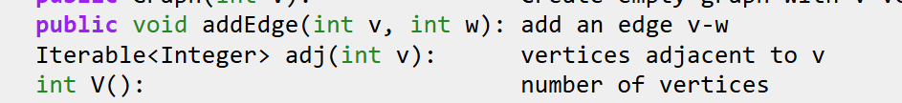

This Iterable<Integer> behaves like a generator

Look

## Adj Matrix

## Edge Sets

Prob too slow, not worth trying

## Adjacency Lists – most popular for sparse graphs

## Not sparse graph?

Buckets?

# Bones

Base API

Specific Implementation – adj matrix, adj list

Storage type

Add Edge, View Adj List, Subtract Edge

Algorithms

Print out a traversal

isConnected?

Shortest Paths

Test Cases

# Heap

Princeton Implementations were not too informative…

Create a Adjacency Matrix version of a graph

Possibly far better version:

<https://www.baeldung.com/java-graphs>

# Design Thoughts

## Structure

GraphBase extended by Storage Method

Adj List

Adj List that stores LinkedList of Nodes ( for if Edge is bidirectional )

Consider if each should be a node

Adj Matrix

GraphBase interface

addVertex

removeVertex

addEdge

removeEdge

Track neighbors – done as adjacency list

Soon: track bidirectional edge

Optional: visualize

Optional: output as CSV file

Optional: track unconnected vertices

Track whatever would be slow to Find via an algorithm, I think

Algorithms:

Track or Find sinks and sources

Find traversals : depth first, etc

Find shortest path from A to B node

Future: convert to minimum spanning tree?